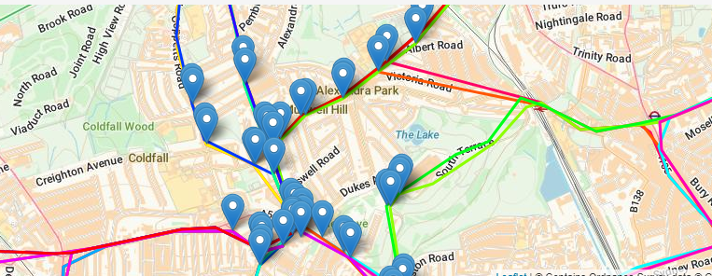
f

Bus Routes in Muswell Hill
- 234 - Barnet, The Spires - Friern Barnet - Muswell Hill - Highgate Wood, school extra
- 234 - Barnet - Muswell Hill - Highgate Woods
- 102 - Edmonton Green - Muswell Hill - Golders Green - Brent Cross
- 184 - Turnpike Lane - Wood Green - Arnos Grove - Barnet, Chesterfield Road
- 299 - Muswell Hill - Southgate - Cockfosters
- W3 - Northumberland Park - Wood Green - Alexandra Palace - Finsbury Park
- 144 - Muswell Hill - Wood Green - Edmonton Green
- 134 - North Finchley - Friern Barnet - Muswell Hill - Highgate - Archway - Kentish Town - Camden Town - Warren Street
- 43 - Friern Barnet - Muswell Hill - Highgate - Archway - Holloway Road - Islington - Moorgate - London Bridge
- 634 - Muswell Hill - Colney Hatch Lane - Friern Barnet - Whetstone - High Barnet - Barnet, Arkley Hotel
- V603 - Muswell Hill Broadway - East Finchley - Highgate - Hampstead - Swiss Cottage
- 603 - Muswell Hill Broadway - East Finchley - Highgate - Hampstead - Swiss Cottage
- 653 - Muswell Hill - East Finchley - Finchley Central - Hendon - West Hendon - Kingsbury
- W7 - Muswell Hill - Crouch End - Finsbury Park
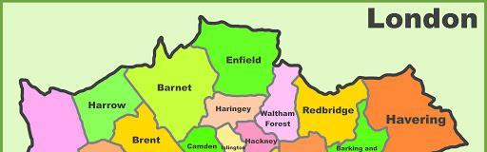

Competency wheel identifying paths

